BABU BANARASI DAS UNIVERSITY



PROJECT
NOSQL & MongoDB (BCADSN13202)

SUBMITTED TO : SUBMITTED BY :
Mr. Ankit Verma Name : Priya Maurya
Uni. Roll No : 1240258336
Section : BCADS25

Q .1 : List the names and departments of students who have more than 75% attendance and are skilled in both "MongoDB" and "Python".

Solution : db.students.find({attendance : {$gt : 85} , skills : {$all : ["MongoDB" , "Python"]}} , {_id : 0 , name : 1, department : 1})
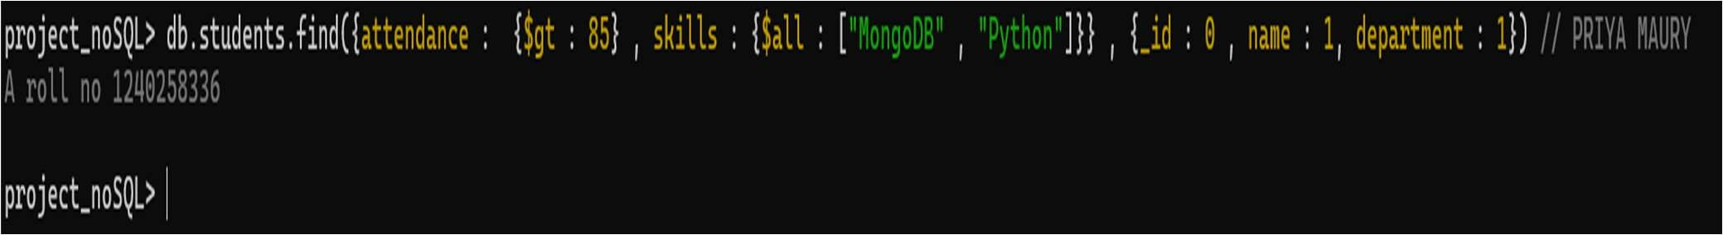

Insights : Uses $all to ensure both skills exist.
Projection only returns name and department.

Q.2 : Show all faculty who are teaching more than 2 courses. Display their names and total number of courses they teach.
Solution : db.faculty.aggregate([ { $project: { name: 1, number_of_courses: {$size: "$courses"
} } }, { $match: { number_of_courses: {$gt: 2 } } } ])
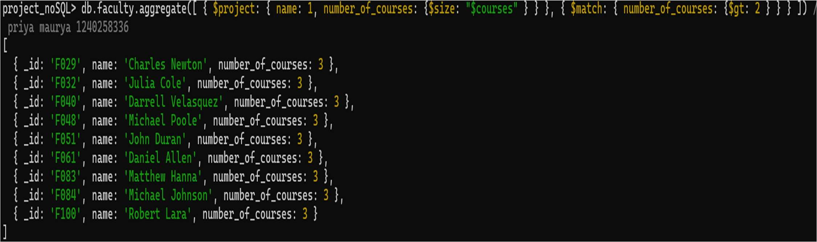
Insights : $size counts array length.
$match filters faculty with > 2 courses.

Q3. : Write a query to show each student’s name along with the course titles they are enrolled in (Use $lookup between enrollments, students, and courses).
Solution : db.enrollmets.aggregate([{$lookup: {from:"students_full",localField: "student_id",foreignField: "_id",as: "student"}},{ $unwind:"$student" },{$lookup: {from: "courses_full",localField: "course_id",foreignField: "_id",as:"course"}},{ $unwind: "$course"
},{$project: {_id: 0,student_name:"$student.name",course_title: "$course.title"}}])
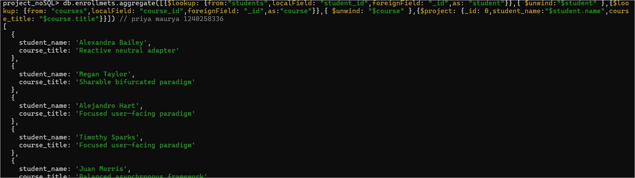
Insights : Performs two joins ($lookup).
$unwind flattens joined arrays.
  - : For each course, display the course title, number of students enrolled, and average marks (use $group).
Solution : db.enrollmets.aggregate([ { $lookup: { from: "courses", localField:"course_id", foreignField: "_id", as: "course" } }, { $unwind: "$course" }, { $group: { _id:"$course_id", course_title: { $first: "$course.title" }, total_students: { $sum: 1 }, average_marks: {$avg: "$marks" } } } ])
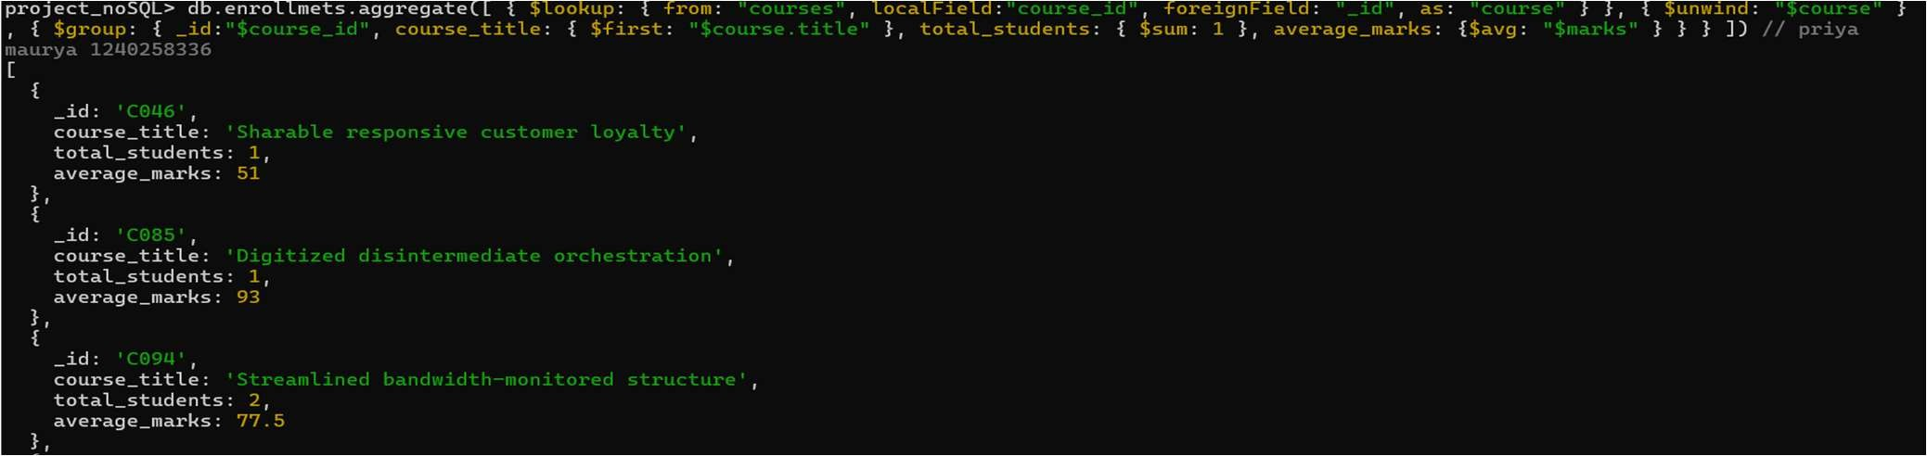
Insights : $group aggregates by course.
$avg computes average marks.

  - : Find the top 3 students with the highest average marks across all enrolled courses.
Solution : db.enrollmets.aggregate([{ $group : { _id : "$student_id" , average_marks : {$avg
: "$marks"}}} , {$lookup : {from: "students" ,localField: "_id" , foreignField : "_id" , as : "student"} } , {$unwind : "$student" }, { $project : { _id : 0 , student_name : "$student.name" , average_marks : 1 } } , { $sort : { average_marks : -1}} , { $limit : 3}])

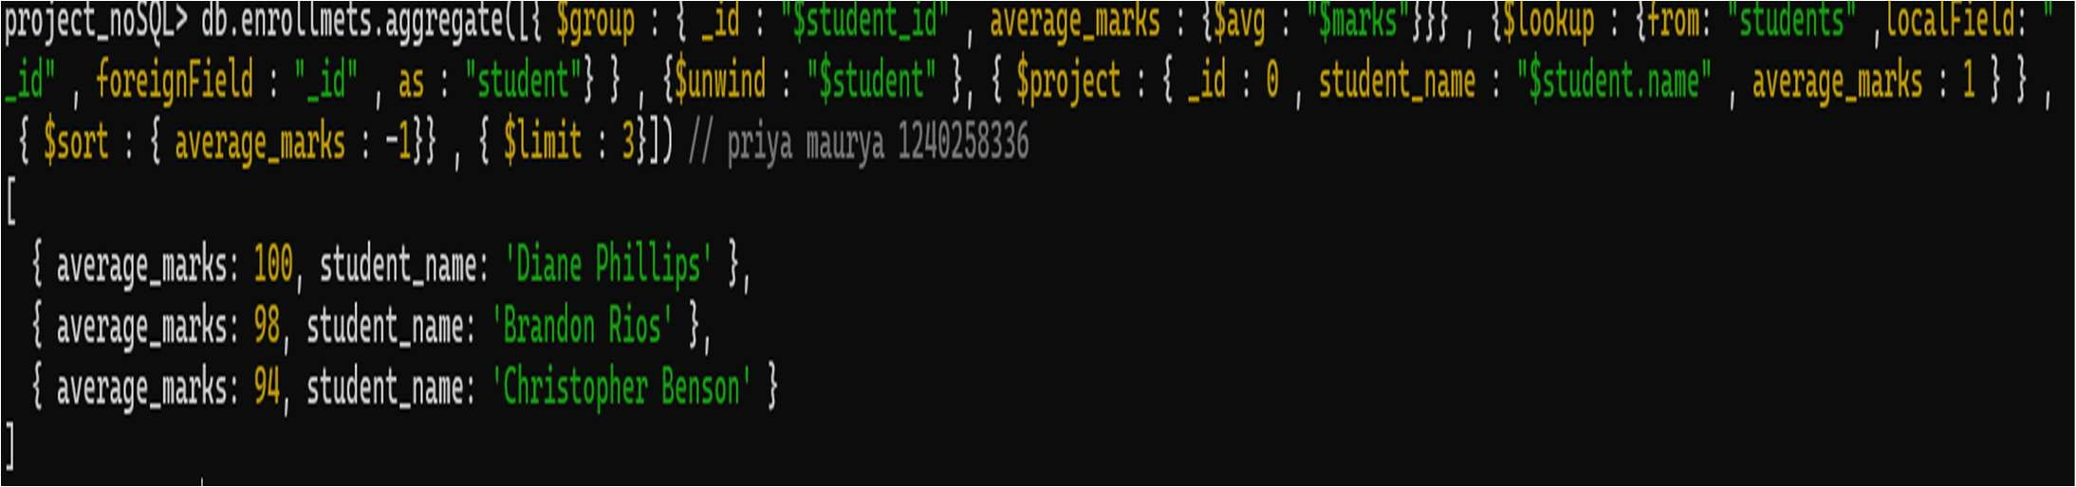
Insights : Combines $group, $sort, $limit, $lookup.

  - : Count how many students are in each department. Display the department with the highest number of students.
Solution : db.students.aggregate([ { $group: { _id: "$department", total_students: {$sum: 1 }
} }, { $sort: { total_students: -1 } }, { $project: { _id: 0, department:"$_id", total_students: 1 } } ])
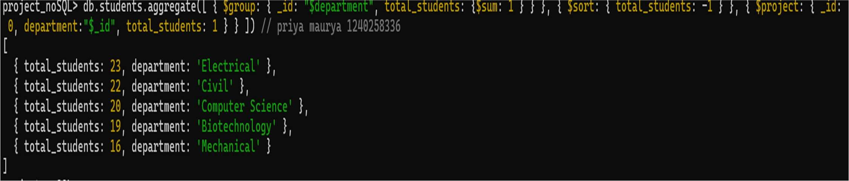

Insight : Combines $group, $sort, $project

Q .7 : Update attendance to 100% for all students who won any "Hackathon".
Solution : db.students.updateMany({ activities : “Hackathon” }, { $set : { attendance : 100}})

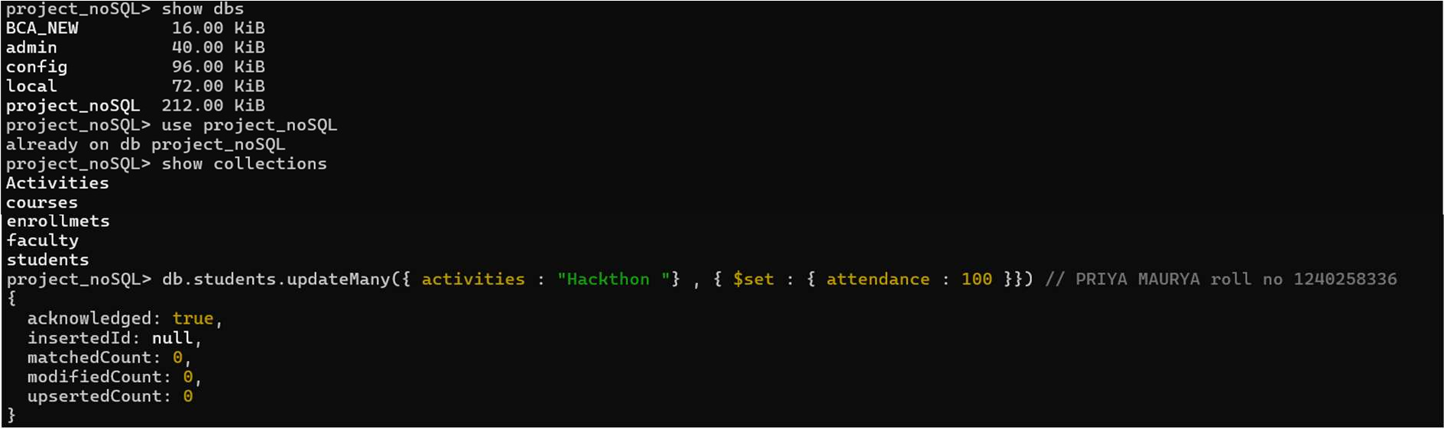
Insight : Use of $set for update data.

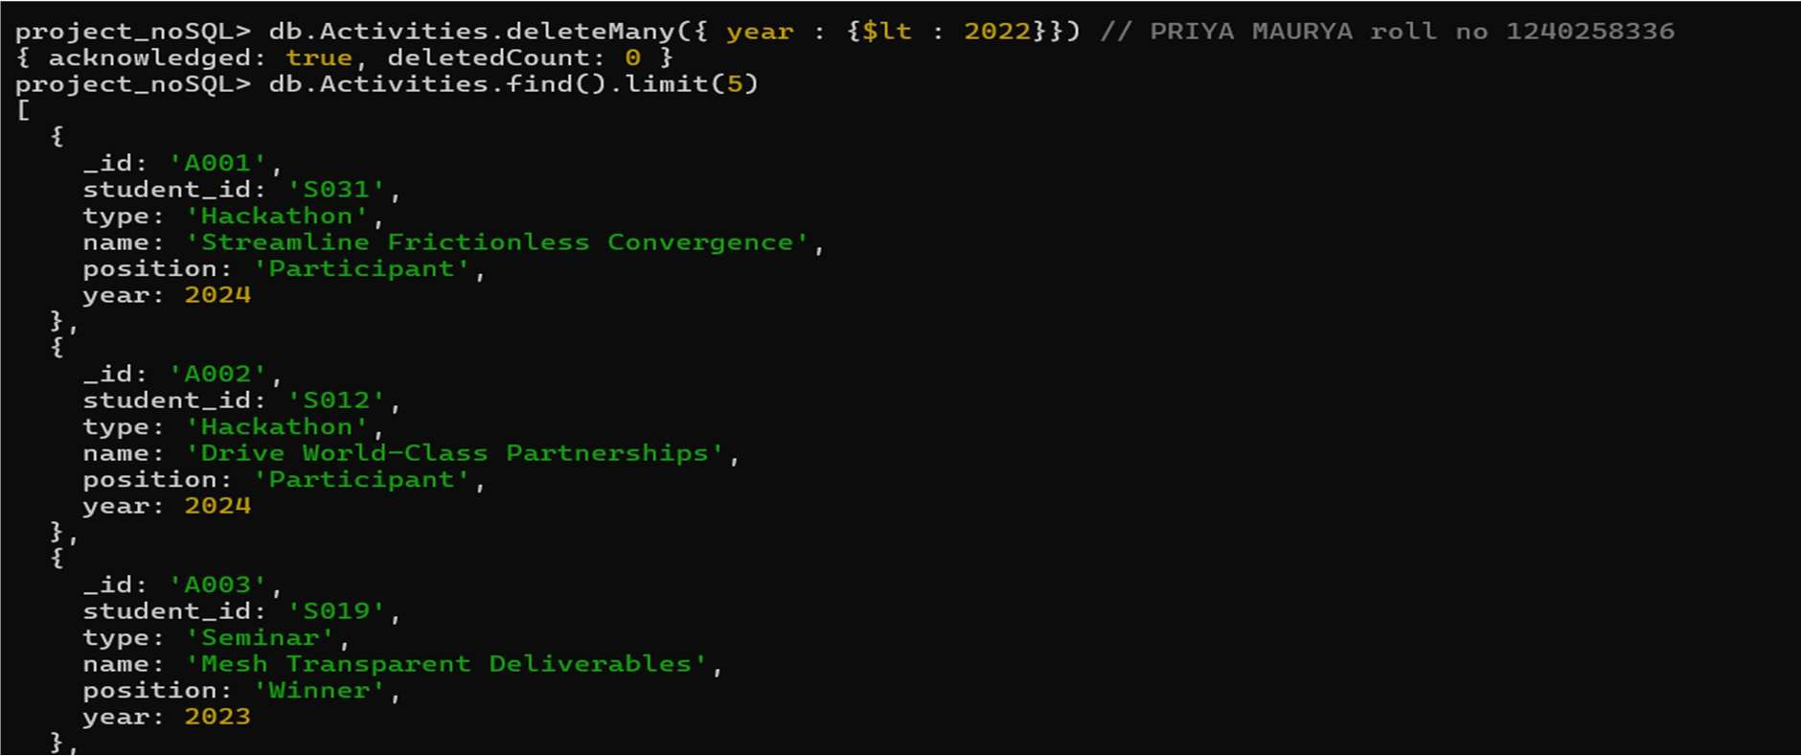
  - : Delete all student activity records where the activity year is before 2022. Solution : db.activities_full.deleteMany({ year: { $lt: 2022 } })
Insight : Use of $lt with deleteMany.

  - : Upsert a course record for "Data Structures" with ID "C156" and credits 4.
If it doesn’t exist, insert it; otherwise, update its title to "Advanced Data Structures".
Solution : - db.courses_full.updateOne({ _id: "C150" },{ $set: { title: "Advanced Data Structures", credits: 4 }
},{ upsert: true })
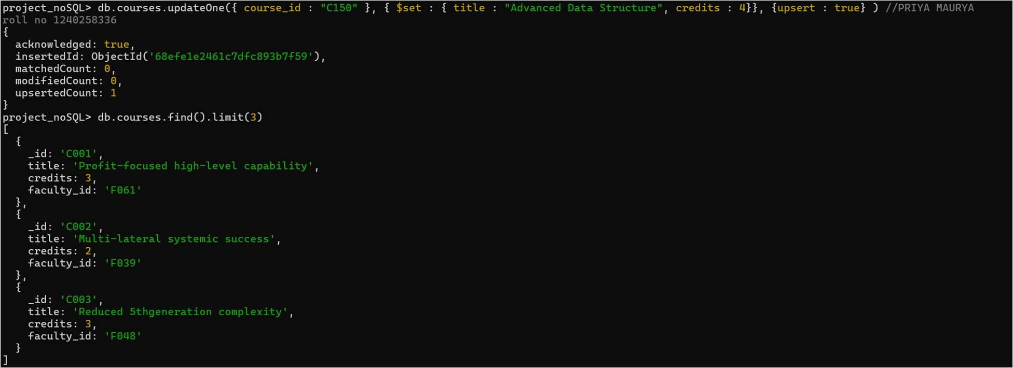

Insight : Combine use of $set , $upsert.

  - : Find all students who have "Python" as a skill but not "C++".
Solution : db.students.find({skills: {$in :["Python"], $nin: ["C++"] }},{ _id: 0,name: 1,skills:1})
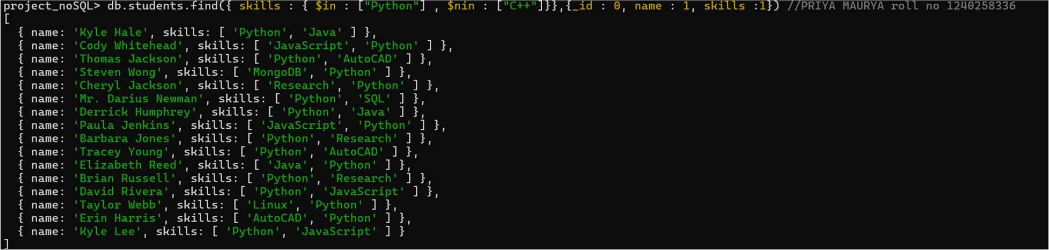

Insight : Use of $in , $nin to filter data .

  - : Return names of students who participated in "Seminar" and "Hackathon" both.
Solution : db.Activities.find ({type : {$in : ["Seminar" , "Hackathon"]}} , {_id : 0 , name : 1 , type : 1})
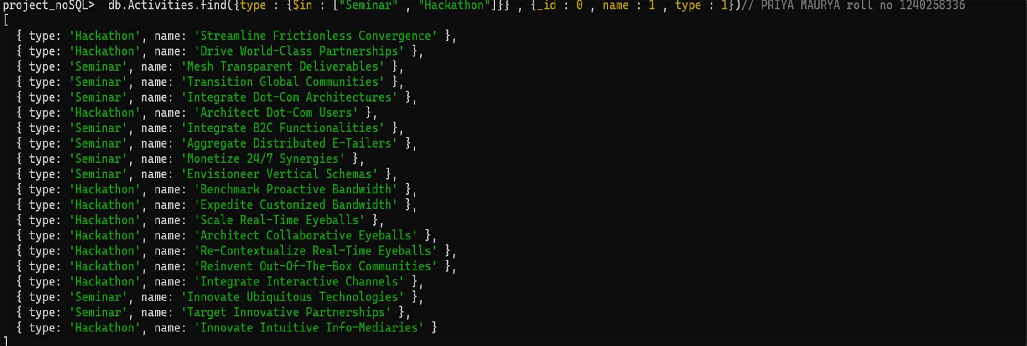

Insight : Filter those students who participated in “Hackathon” , “Seminar”.

  - : Find students whose attendance more than 95 % only if they belong to the "Computer Science" department.

Solution : db.students.find({ department : “Computer Science” , attendance : { $gt : 95}] , { _id : 0, department: 1 , attendance : 1})
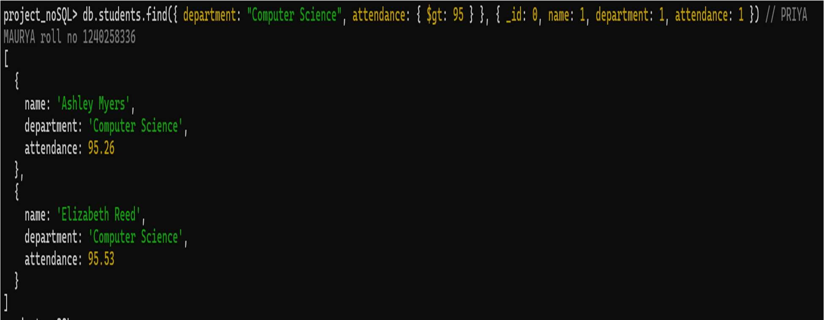
Insight : Filter students on attendance more than 95 % using $gt.

  - : For each faculty member, list the names of all students enrolled in their courses along with average marks per student per faculty.
Solution : db.courses.aggregate([ { $lookup: {from: "enrollmets", localField:"_id", foreignField: "course_id", as: "enrollments" } }, { $unwind: "$enrollmets" }, { $lookup: { from:"students", localField: "enrollmets.student_id", foreignField: "_id", as: "student" } }, { $unwind:"$student"
}, { $group: { _id: "$faculty_id", students: { $addToSet: "$student.name"
},average_marks_per_student: { $avg: "$enrollmets.marks" } } }, { $lookup: { from: "faculty",localField: "_id", foreignField: "_id", as: "faculty" } }, { $unwind: "$faculty" }, {
$project: { _id: 0,faculty_name: "$faculty.name", students: 1, average_marks_average_marks_per_student: { $round:["$average_marks_per_student", 2] } }
} ])
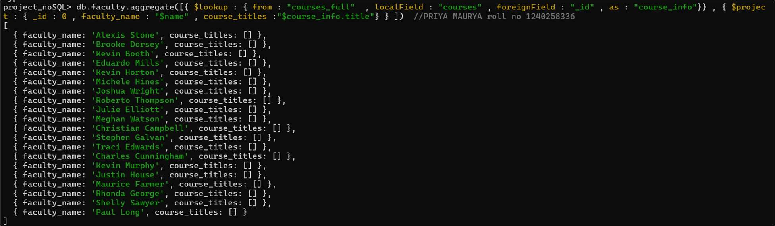
Insight : Combines $group, $project , $lookup.

  - : Show the most popular activity type (e.g., Hackathon, Seminar, etc.) by number of student participants.
Solution : db.Activities.aggregate([ { $group: { _id: "$type", participants: {$addToSet: "$student_id" } } }, { $project: { _id: 0, activity_type: "$_id", number_of_participants: {$size: "$participants" } } }, { $sort: { number_of_participants: -1 } }, { $limit: 1 } ])
Insight : Combines $group, $sort, $limit,$project , $size .

